 Indian School Al Wadi Al Kabir
Assessment 2
INFORMATICS PRACTICES (Code: 065)
CLASS : XI Max. Marks:70
Date: Time: 3 hours
General Instructions:
Please check this question paper contains 37 questions.
● All questions are compulsory.
● The paper is divided into 5 Sections- A, B, C, D and E.
● Section A consists of 21 questions (1 to 21). Each question carries 1 Mark.
● Section B consists of 7 questions (22 to 28). Each question carries 2 Marks.
● Section C consists of 4 questions (29 to 32). Each question carries 3 Marks.
● Section D consists of 2 questions (33 to 34). Each question carries 4 Marks.
● Section E consists of 3 questions (35 to 37). Each question carries 5 Marks.
● All programming questions are to be answered using Python Language only.
● In case of MCQ, text of the correct answer should also be written.

 | SECTION A
1. | Which of the following is correct?  - Keywords can be used as a variable name.  - Variable name can start with a digit.  - Variable name can start with an underscore.  - Variable name can have symbols like: @,#,$ etc. | 1
2. | Evaluate: not(1= =1 and 0!=1)  - True  - False  - Error  - Cannot say | 1
3. | ___________ is use to compare NULL values  - Between  - is  - and  - or | 1
4. | What is the full form of DBMS?  - Data of Binary Management System  - Database Management Service  - Database Management System  - Data Backup Management System | 1
5. | Which command is used to delete a column from a table:  - Update  - Delete  - Drop  - Alter | 1
6. | Which of the following is not an input device?  - Keyboard  - Monitor  - Joystick  - Microphone | 1
7. | Rohan is developing in program in python when he is taking whole number, result of  program is correct but when he is taking decimal values, he is not getting result  according to decimal values. He is getting result on basis of whole numbers,  what he should do to get the accuracy in result.  - Re - write the program  - Give comment in program  - Change int data type int to float  - Change int data type float to int | 1
8. | Mr. Milan is using a table with following columns:  Name, Class, Stream_Id, Stream_Name.  He needs to display names of students who have not been assigned any stream or have been assigned Stream_Name that ends with ‘computers’. He wrote the following command, which did not give the desired result.  SELECT Name, Class FROM Students WHERE stream_Name=NULL or Stream_Name=’%computers’;  Help Mr. Milan to run the query by removing the error and write correct query.  - SELECT Name, Class FROM Student WHERE stream_Name = NULL or Stream_Name LIKE’%computers’;  - SELECT Name, Class FROM Student WHERE stream_Name IS NULL or Stream_Name LIKE’%computers’;  - SELECT Name, Class FROM Student WHERE stream_Name IS NULL or Stream_Name =’%computers’;  - SELECT Name, Class FROM Student WHERE stream_Name IS NULL or Stream_Name LIKE ‘computers%’; | 1
9. | To specify a list of values in SQL ___________ Operator is used.  - In  - Like  - Between  - Is | 1
10. | Which is not a function of DML?  - Retrieval of data stored in the database  - Insertion of data into the database  - Deletion of data from the database  - Making changes permanent to the database. | 1
11. | Write a python statement, to delete the item from the dictionary corresponding to the key 9 of the following dictionary, ODD = {1:'One',3:'Three',5:'Five',7:'Seven',9:'Nine'}. | 1
12. | What will be the output of the following code?  list1=[8,0,9,5]  print(list1[::-1])  - [5,9,0,8]  - [8,0,9]  - [8,0,9,5]  - [0,9,5] | 1
13. | What is the permanent memory built into your computer called?  - RAM  - ROM  - CPU  - CD-ROM | 1
14. | Which of the following is the common measurement of unit of computer memory?  - IQ  - Byte  - Terabyte  - Gigabyte | 1
15. | State True or False.  “An operating system is a program which acts as an interface between the user and the hardware”  - True  - False | 1
16. | Which statement contains error in following Python Code:  for x in (3,9,3):  print(“Hello”)  else:  print(Entry)  - print(Entry)  - else:  - print(“Hello”)  - for x in (3,9,3): | 1
17. | What will be the output of the following Python code?  a={1:”A”,2:”B”,3:”C”}  a.clear( )  print(a)  - None  - { None:None, None:None, None:None}  - {1:None, 2:None, 3:None}  - { } | 1
18. | Keys of the dictionary must be:  - Similar  - Unique  - Can be similar or unique  - All of these | 1
19. | To add a new element to a list we use which Python  command?  - list1.addEnd(5)  - list1.addLast(5)  - list1.append(5)  - list1.add(5) | 1
Q-20 and Q-21 are Assertion (A) and Reason (R) Type questions.
Choose the correct option as:
- Both A and R are True, and R correctly explains A.
- Both A and R are True, but R does not correctly explain A.
- A is True, but R is False.
- A is False, but R is True.
20 | Assertion (A): - The keyword DISTINCT is used to eliminate redundant data from a table.  Reasoning (R): - WHERE clause is used to select specific rows. | 1
21. | Assertion: List is mutable data type  Reasoning: We can update the values of list elements like l[1]=5 | 1
 | SECTION B
22. | What is difference between Primary key constraint and unique constraint in MySQL? Explain with example. | 2
23. | Write MySQL command to create the table SHOP with given structure and constraint. | 2
  Column_Name | DataType(size) | Constraint
  Fno | Int (10) | Primary Key
  Fname | Varchar (15) | Unique
  Type | Char (10)
  Stock | Int (3)
  Price | Float(10,2) | Not Null
24. | Write Python statements for performing the following on a dictionary, “School”.  - To check whether the value “s1” is existing as the dictionary’s keys  - To find the number of elements in a dictionary  - To change the value corresponding to “s5” to 99  - To display the key value pairs available in the dictionary School. | 2
25. | Predict the output based on the list,  cod = [98, 45, 62, 14, 1007]  - print(len(cod+cod))  - print(cod[2:4] * 3)  - print(50-5 not in cod)  - print(cod[::-1]+cod[0:1]) | 2
26. | Arvind is learning MySQL for managing different databases and tables for his Python based application/software. Help him to write the SQL commands for the following:-  - How to show pre-existing databases.  - How to open a desired database ‘school’. | 2
27. | What is the difference between DELETE and DROP commands of SQL? Explain with example. | 2
28. | Write a python program to print factorial of a number. | 2
 | SECTION C
29. | What will print on screen after execution of given code:  s,p=0,1  for x in range(1,10,2):  s+=x  p*=x  print('final x=',x)  print('sum =',s)  print('product=',p) | 3
30. | - What do you mean by cache memory?  - Give two examples of operating system.  - What is the difference between Primary memory & Secondary memory? | 3
31. | Write a Python program to accept a list L1 from the user and calculate and print the sum of all odd and even elements separately. | 3
32. | Write the output of the following code python code segment.  List1 = [20, 40, 30, 50, 60, 40, 50, 30, 10, 20, 60, 30]  print(List1.pop(1))  print(List1.pop())  List1.index(30)  List1.remove(60)  print(List1)  List1.append([15,78])  print(len(List1))  List1.insert(5,100)  print(List1)  print(List1.count(30) * List1.count(60)) | 3
 | SECTION D
33. | Write a program that repeatedly asks the user to enter Name of the month and its number of days (from January to December). Store all of them in a dictionary ‘Month’ and display the number of days in the given month, based on the dictionary Month, which has number of the month as keys and the number of days as values. | 4
34. | - Explain pop() and remove in list with example.  - Explain update() in dictionary with example.  - Explain Concatenation in List with example.  - Explain sort() in list with example. | 4
 | SECTION E
35. | Consider the table ‘EMP” given below.  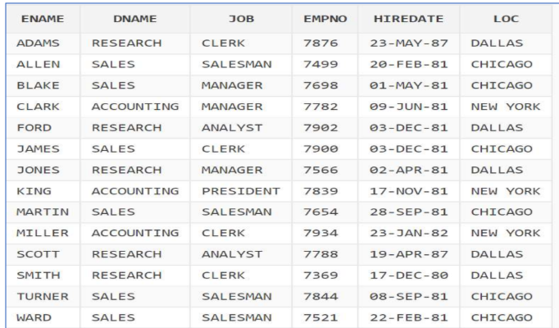  - Write a command to display details of employee whose job type is either CLERK or SALESMAN.  - Write a command to display name of employee with their job type.  - Write a command to display distinct job types from table emp.  - Write a command to display name of employees whose Department name is not given.  - Write a command to delete all the rows from table emp. | 5
36. | Consider the table RESULT given below Write commands in MySQL for (i) to (iv) and output for (v) :  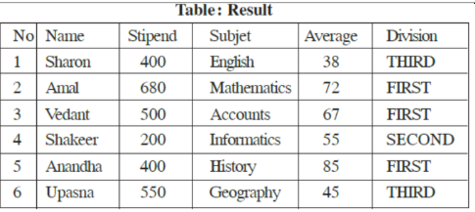  (i) To list the names of those students, who have obtained Division as  FIRST in the ascending order of Name.  (ii) To display a report listing NAME, SUBJECT and Stipend received.  (iii) To increase stipend by 500 for those who got average above 65  (iv) To insert a new row in the table Result: 7, "Mohan", 500,  "English",73,"Second";  (v) Select * from Result where Division in(‘First’,’Third’); | 5
37 | Consider the table ‘Teacher’  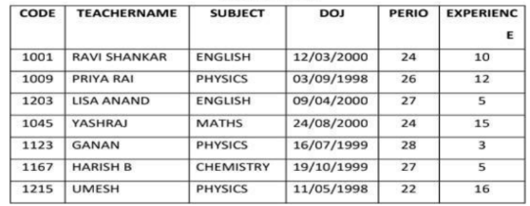  - Write a MySQL query to change CODE as a primary key after the creation of the table ‘Teacher’.  - Write a MySQL query to add a column SALARY to the table Teacher.  - Write a MySQL query to remove the column EXPERIENCE from the table.  - Write a MySQL query to display the details of the teachers whose periods come in the range 26 to 28(Both values inclusive)  - Write a MySQL query to remove the details of the teachers whose name contains letter ‘R’ | 5

